Fall 2020 CISC 4900 Project Proposal

Name: Chia Zheng, Romer Gil
CUNY First ID: 23625144
Address: 1823 82nd ST, Fl 1, Brooklyn, NY11214
Telephone: (929) 264-0420
Email: romerchia@hotmail.com
Major: Computer science
Relationship: I am Student of class CISC 3320 Operating System of Professor Hui Chen.

Name: Ng Lawrence
CUNY First ID: 23188682
Address: 90 Avenue D Apt 13F,Manhatton,NY10009
Telephone: (718) 530-8842
Email: Lawrence.ng2013@gmail.com
Major: Information System
Relationship: No personal, business or professional relationship with Professor Chen

Course Number: CISC 4900
Semester: Fall 2020
Agency: Brooklyn College

Supervisor: Hui Chen
Telephone: (718)951.5000 x2055
Address:
Email: chen@sci.brooklyn.cuny.edu

Reasons of doing social media web
We are interested in creating a social media website application for several seasons: 1. We want to use all knowledge we learn from our class to create a website, refresh our remember of those programming skills and test our limits. 2. Social media are very popular in these years. Therefore, having full stack experience will increase the chances of getting a job. 3. Having an experience working with others in a limit of time will become a good practice for the real-life development job (working as a development team is totally different from learning in college.) 4. Learning a new programming skill in a limit of time is not easy, however it will happen all the time in the real development job. Having those experience earlier can also help finding and adapting a job much faster. (The reason of choosing C# and ASP.NET are: 1. Lesser Code: ASP.NET is a technology that help us as a developer to easily optimize the code-structure by means of writing much lesser statements. As coding is less, the smaller number of hours are required in order to create an application, which improves efficiency. 2. Easier Maintenance. It is not easy for developers who have less experience in developing application to maintenance the full stack servers. Therefore, less code and ASP.NET’s built-in functions helps to maintain and pinpoint errors/bugs easier.)
Thus, with CIS Professor Hui Chen’s help, we will create a functional social media website application.
System Design

Design a simple model of social media where people can add other people as friends. In addition, where people can post messages and that messages are visible on their friend's page.

Use Case
- A user can create their own profile.
- A user can add other users to his friend list.
- Users can post messages to their timeline.
- The system should display posts of friends to the display board/timeline.
- People can like a post.
- People can share their friends post to their own display board/timeline.

Constraints
- Consider a whole network of people as represented by a graph. Each person is a node and each friend
- Total number of distinct users / nodes: Because we are designing very simple social media application compare to real world , so we are thinking of about 1000. (In the real word , it should be at least 1 million.)
- Total number of distinct friend’s relationship / edges in the graph: 10* 10 (again , in the real world at least 100 * 10 million)
- Number of messages posted by a single user per day: 5
- Total number of messages posted by the whole network per user: 10 * 10

Basic Design
Our system architecture is divided into two parts:
- First, the web server that will handle all the incoming requests.
- The second database, which will store the entire person's profile, their friend relations and posts.

First, three requirements creating a profile, adding friends, posting messages are written some information
to the database. While the last operation is reading data from the database.

The system will look like this:
- Each user will have a profile.
- There will be a list of friends in each user profile.
- Each user will have their own homepage where his posts will be visible. A user can like any post of their friend and that likes will reflect on the actual message shared by his friend.

If a user shares some post, then this post will be added to the user home page and all the other friends of the user will see this post as a new post.

Scalability
Since there is a heavy load, we need horizontal scaling many web servers will be handling the requests. In doing this we need to have a load balancer, which will distribute the request among the servers. This approach gives us a flexibility that when the load increases, we can add more web servers to handle the increased load.

Database Schemas
Here are the schemas so far (It is possible have some changes compare to final version)

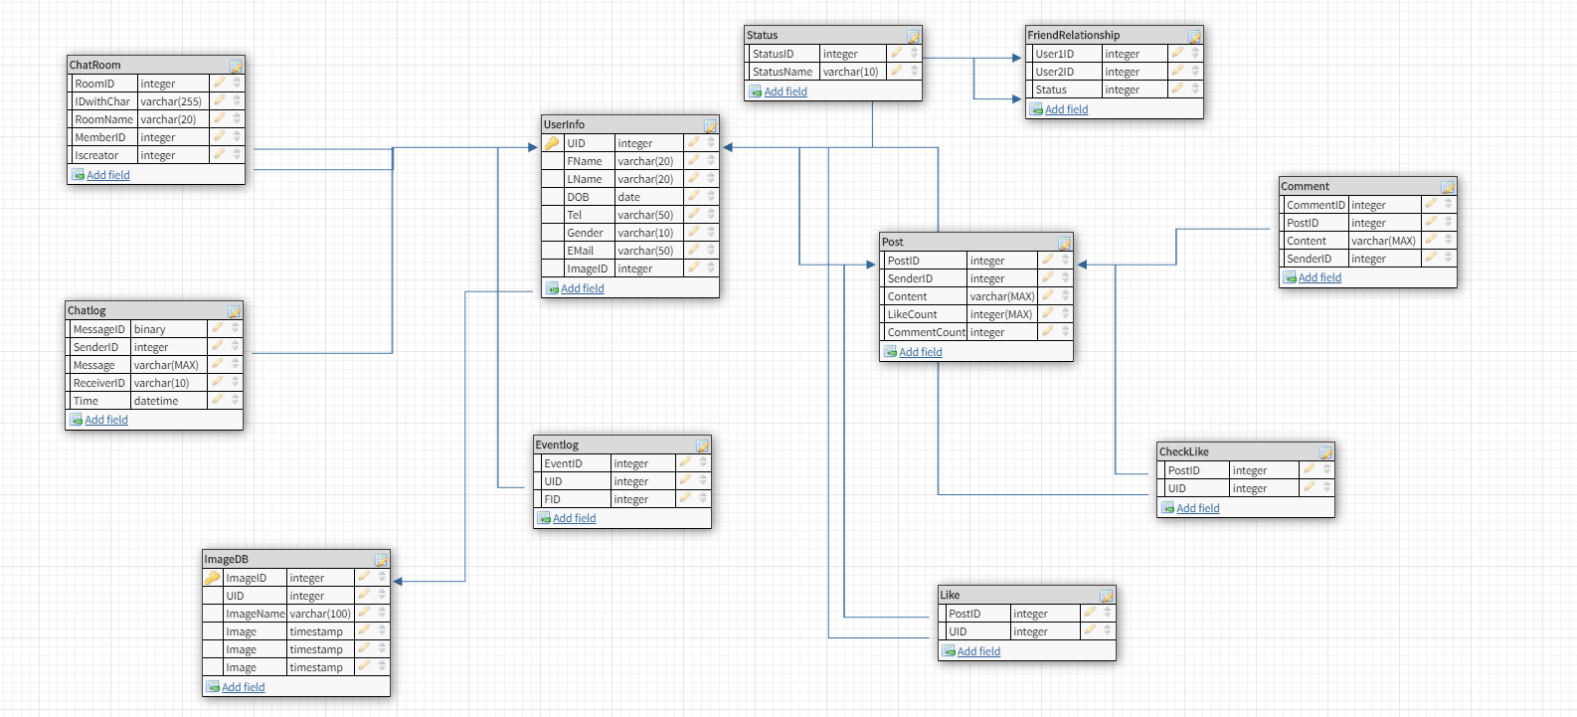

Proposed solution

- Create responsive website Front-End
Tool and Language: ASPX, CSS, JavaScript
- Home Page
- Register Page
- Log in Page
- About Page
- User Page
- Friends Page
- Other relative Pages (Chat, search result….)

- Database System
Tool and Language: SQL server Database
      - User Table
      - Message Table
      - Friends table
      - Other relative tables

- Back-End
Tool and Language:
C#
- Access to Database
- Function for the website
- Connection to Front-End

- Chat history automatic sync
- Use Ajax to refresh message by a settled time.
- Use Web Socket to refresh message once it is updated.

- Web security
- Run at server
- Data protection

- Database Security
- System Configuration for Connecting to Server
- Stored Procedure for database security.

- Responsive Web Design
- How to approach a layout
- CSS units(absolute , relative and percentages)
- Flexbox basics
- Media query basics

